**Student name**_______________________

Date issued _____________ Due End Oct 2012

**Rangiora Rebuild**

**Situation:**

Rangiora business, commercial and residential sectors have been affected by the earthquakes and aftershocks in the same way as Christchurch CBD. The scale may be smaller but the devastation is felt here just as much. This natural disaster, presents you with an opportunity to develop and transform Rangiora into a township ***more appropriate for the expectations of the 21st century***

We have seen the new ‘pop-up’ centre in Christchurch and how successful it has been in bringing life and business back to the central city.

Rangiora could *learn, adapt and improve on* this success

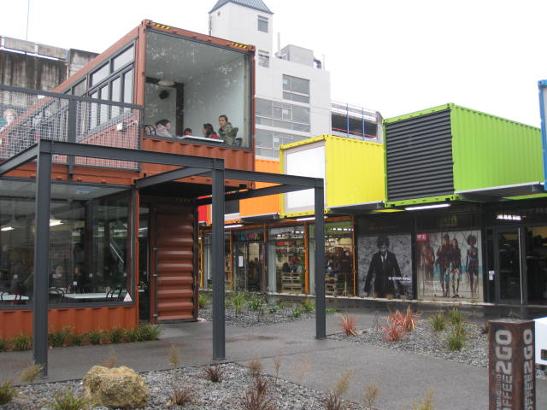

Open plan, pedestrian walkways

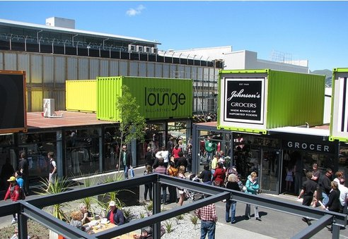

Bold colours – lots of glass

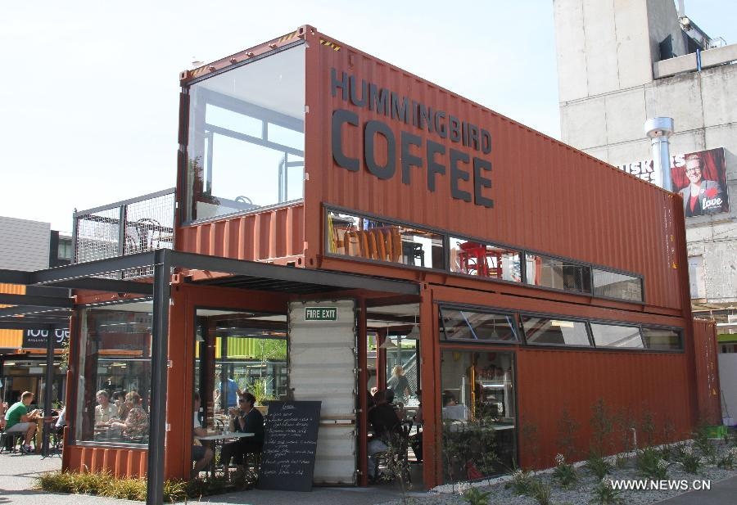

Vertical lines – implying strength

Shrubs and plants – suggesting tranquillity

**Brief:**

Design and draw **a set of plans** for a temporary dwelling/unit that will meet the needs of **one** of the following:



* Homeless family of four – 2 adults 2 children
* Medical emergency unit
* USAR Team- urban search and rescue
* Food kitchen
* Retail outlet
* Other by negotiation

### Special notes:

* Use the sizes of a standard ship container as a *basis* for your design but **Do not use a shipping container as your design - it’s been done (think of a shoebox instead!)**
* When you have chosen your context, research the requirements necessary for it to **function**-fit for purpose, and be **aesthetic**ally successful-a quality design (use architect research to define and deliver quality)
* Locate and identify a suitable stakeholder to guide you

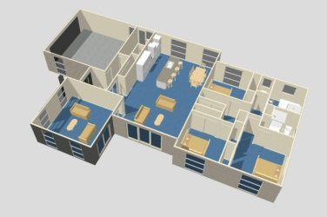

**Specifications**

**The unit must be:**

* portable
* weather-proof
* secure
* able to hook–up to services (water power sewage)
* clad with suitable internal walls and decor
* modelled on the best available ‘kitsets’ available ‘Trendz/A1 Homes/Versatile Homes
* utilising cost effective and recycled materials
* uniquely assembled
* fit for intended purpose
* easily identifiable – your logo in a prominent location



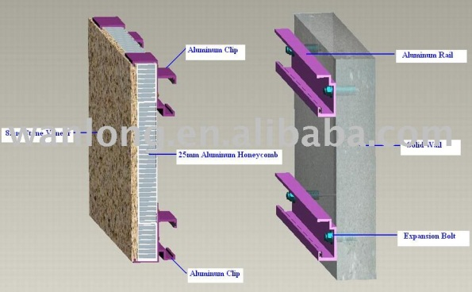

***Student guidelines/instructions***

1. Write a personal statement that specifies the requirements for the brief, including reference to at least 2 societal and/or environmental priorities you will consider. Explain and justify the inclusion of these considerations in your design.
2. Your solution must conform to the concept of *sustainability* (research what this term means)
3. Investigate and **identify** (N/A) the work of a New Zealand based or world-wide architect. Present a visual overview of their work and discuss how they may have influence over your outcome. Include as the opening sheets and the base research to your communication portfolio.

**Describe** (Ach) the design elements which are evident in their work and contribute to the quality of the design (refer **1.10** NZQA AS for definitions).

**Explain** (Merit) how the *design elements impact on the quality* of the design a) *subjectively*-opinions and views of self and others, and b) *objectively*- measurable details, costs, profit, awards, media exposure, environmentally-impact of and consideration for.

**Explore** (Exc.)the implications for this design on society at all levels- individuals of all age groups, family/whanau, sports/music/hobby groups, schools, universities, shop/retail owners, business owners, charities, and the country’s economy.

1. [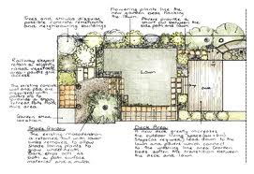](http://www.google.co.nz/imgres?q=planning&hl=en&sa=X&rlz=1W1ADRA_enNZ417&biw=1280&bih=521&tbm=isch&prmd=imvnsb&tbnid=S6nlTTLHyuBXwM:&imgrefurl=http://www.shelleygroves.co.nz/how-i-work/&docid=bqRbn9J5jjtoeM&imgurl=http://www.shelleygroves.co.nz/how-i-work/img/plan-02.gif&w=412&h=283&ei=RPNCT-qrAs2iiAf7hemCBA&zoom=1)Research, and present (digitally or on A3 paper) and evaluate in detail (refer to literacy guide sheet & point 3 above) a range of ideas from online or magazines that show:

* Interior/living designs
* interior and exterior lighting systems
* shelving units
* widow displays
* emergency vehicle layout
* security systems
* ‘clip on’ units
* anything that is pertinent to a solution

[](http://www.google.co.nz/imgres?q=planning&hl=en&sa=X&rlz=1W1ADRA_enNZ417&biw=1280&bih=521&tbm=isch&prmd=imvnsb&tbnid=NgUNIwXfFOorEM:&imgrefurl=http://www.dalwoo.com/the-skill-of-planning.html&docid=joioOgbj8x3STM&imgurl=http://www.dalwoo.com/wp-content/uploads/2011/10/board_planning.gif&w=330&h=308&ei=RPNCT-qrAs2iiAf7hemCBA&zoom=1)Your evaluation should include notes that refer to the design elements and principles identified earlier during the architectural study, and the features and benefits of any ideas you see relevant from your research. You must include a commentary stipulating some ideas that you will use/develop further, and which will have a positive impact on the quality of the overall design aesthetic and function.

1. Establish the requirements to gain any local resource consent for such an undertaking (guest speaker from the council? Email sent to Jim Palmer CEO of Waimakariri Council 24th Feb 2012 advising of the project and students brief)
2. Establish a contact (stakeholder) **in your chosen context** to guide your work.
3. With reference to your research, generate a series of freehand concept ideas, both 2-D and 3-D, showing a range of options for overall solution. Use annotation to clarify these ideas e.g. how people will move from one area to another or storage heights working heights dead space etc. Use annotated 2-D and 3-D sketches of your possible solutions.

Add rendering to the concepts, and shadow to enable the reader to fully visualise your thinking.

1. Evaluate these ideas with regard to the design specifications including any societal/environmental considerations. Whilst completing the evaluation, make reference to the principles and elements of design. You may comment on how patterns, style, lines etc can affect the overall impression of a room and even detract from the overall aesthetic.
2. Produce a series 3D sketches, using instrumental paraline drawing techniques; isometric, oblique, that will generate internal and external design detail. This can include cut-away views of internal/external wall construction.

Evaluate these sketches using design language, against the specifications.

1. Indicate where you have made reference to the design principles and elements in the development of your solution and provide clear evidence of on-going evaluation particularly between each stage of the solution’s development. Decisions made throughout this design process need to be justified and evaluated as to their impact on the outcome’s quality.

1. Produce to scale, using the relevant drawing standards hand-drawn or ICT produced (NZ/AS 1100), 3rd angle orthographic, instrumental drawings of the:

* completed temporary dwelling



* innovative security systems or custom build additions
* fixtures and fittings (desks/tables/cupboards etc – you have designed specifically fit for the purpose)

**PLUS**

instrumental pictorial views of all components

instrumental pictorial view of the unit in situ

1. Evaluate your final solution in terms of the specifications and your priorities.
2. Bringing it all together:

* Assemble your communication portfolio **in a manner that will be presented to a client** (Possibly the Waimakariri council) which considers the NO CRAP composition principles to effectively visually communicate your design thinking and solutions to the issue presented.

**Reminder:** Develop your ideas, using sketches and notes, to reach a solution that meets the requirements of the brief. Evaluate these ideas with regard to the design specifications, societal considerations and the principles and elements of design.

#### For your information we include the “language of design”

Aesthetics Colour Contrast

Clarify Justification Environment

Societal Specifications

Rhythm Function Environment

Balance

Form Proportion

#### See how often you can use these words in your annotations



[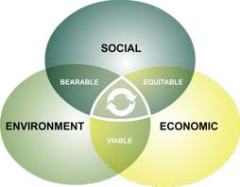](http://www.google.co.nz/imgres?q=sustainability&hl=en&sa=X&qscrl=1&nord=1&rlz=1T4ADRA_enNZ417NZ420&biw=1280&bih=521&tbm=isch&prmd=imvnslb&tbnid=mLliaqj1eKQrgM:&imgrefurl=http://drsuneelsethi.wordpress.com/2011/02/20/communicating-the-%25E2%2580%259Csustainability%25E2%2580%259D-message/&docid=wMr_FCT03_7F1M&imgurl=http://drsuneelsethi.files.wordpress.com/2011/02/sustainability_graphic.jpg&w=380&h=296&ei=y_RCT8fdKMe3iQeF5dXNBA&zoom=1)

[](http://www.google.co.nz/imgres?q=sustainability&hl=en&sa=X&qscrl=1&nord=1&rlz=1T4ADRA_enNZ417NZ420&biw=1280&bih=521&tbm=isch&prmd=imvnslb&tbnid=IKuUsfjtMmZ_kM:&imgrefurl=http://justincaseyouwerewondering.com/2011/10/24/sustainability/&docid=qUZ-cHdAlcQ0sM&imgurl=http://justincaseyouwerewondering.com/wp-content/uploads/2011/10/sustainability.jpg&w=308&h=307&ei=y_RCT8fdKMe3iQeF5dXNBA&zoom=1)

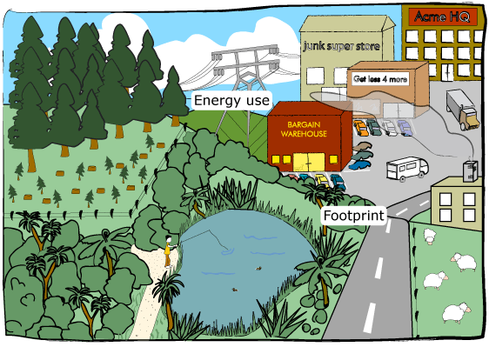

[](http://www.google.co.nz/imgres?q=sustainability&hl=en&sa=X&qscrl=1&nord=1&rlz=1T4ADRA_enNZ417NZ420&biw=1280&bih=521&tbm=isch&prmd=imvnslb&tbnid=D1I-RF0uJYNIuM:&imgrefurl=http://eventsforchange.wordpress.com/2011/04/28/why-sustainability-is-not-%25E2%2580%259Cgood%25E2%2580%259D/&docid=XeWiHfKAlGeYHM&imgurl=http://eventsforchange.files.wordpress.com/2011/04/aint_easy_being_green.jpg&w=347&h=450&ei=y_RCT8fdKMe3iQeF5dXNBA&zoom=1)

Well that went well – NOT!



sustainability